Project Design Phase-II
Data Flow Diagram & User Stories

Date | 31 January 3035
Team ID | SWTID-2026-3968
Project Name | AI FAQ Assistant
Maximum Marks | 4 Marks

Data Flow Diagrams:
A Data Flow Diagram (DFD) is a traditional visual representation of the information flows within a system. A neat and clear DFD can depict the right amount of the system requirement graphically. It shows how data enters and leaves the system, what changes the information, and where data is stored.
Example: DFD Level 0 (Industry Standard)
Example: (Simplified)
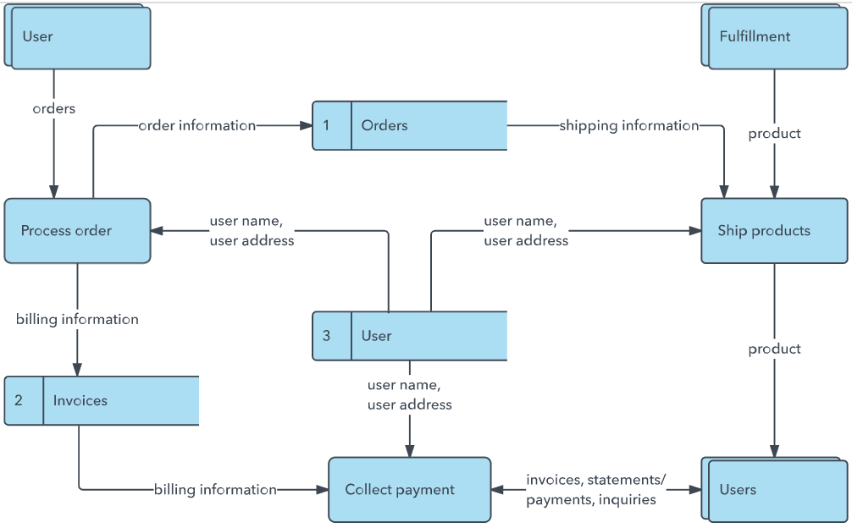


User Stories
Use the below template to list all the user stories for the product.
User Type | Functional Requirement (Epic) | User Story Number | User Story / Task | Acceptance criteria | Priority | Release
Customer (Mobile user) | Registration | USN-1 | As a user, I can register for the application by entering my email, password, and confirming my password. | I can access my account / dashboard | High | Sprint-1
 |  | USN-2 | As a user, I will receive confirmation email once I have registered for the application | I can receive confirmation email & click confirm | High | Sprint-1
 |  | USN-3 | As a user, I can register for the application through Facebook | I can register & access the dashboard with Facebook Login | Low | Sprint-2
 |  | USN-4 | As a user, I can register for the application through Gmail |  | Medium | Sprint-1
 | Login | USN-5 | As a user, I can log into the application by entering email & password |  | High | Sprint-1
 | Dashboard
Customer (Web user)
Customer Care Executive
Administrator

Implemented Data Flow Diagram
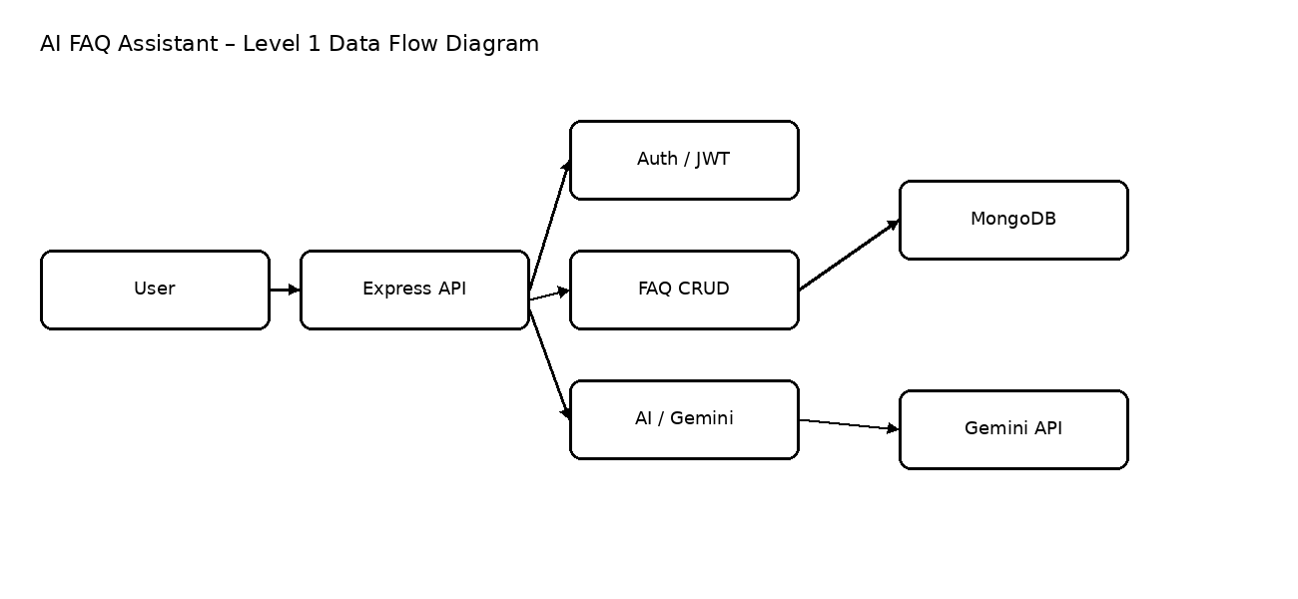
User Stories
User Type | Functional Requirement (Epic) | User Story Number | User Story / Task | Acceptance criteria | Priority | Release
User | Authentication | USN-1 | As a user, I can register with name, email and password. | Valid data creates account; password is hashed; duplicate email is rejected. | High | Sprint-1
User | Authentication | USN-2 | As a user, I can log in with email and password. | Valid credentials return JWT; invalid credentials return 401. | High | Sprint-1
User | Authentication | USN-3 | As a user, I can retrieve my profile after login. | Bearer token returns authenticated profile. | Medium | Sprint-1
User | FAQ Search | USN-4 | As a user, I can view and search FAQs. | Public FAQ endpoints return matching records. | High | Sprint-1
FAQ Owner | FAQ Management | USN-5 | As an authenticated owner, I can create an FAQ. | Valid category and content create a record linked to the user. | High | Sprint-2
FAQ Owner | FAQ Management | USN-6 | As an authenticated owner, I can update/delete my FAQ. | Only the creator can modify or delete the record. | High | Sprint-2
User | AI Assistant | USN-7 | As an authenticated user, I can ask a question and receive an AI answer. | Valid question returns a Gemini answer or structured error. | High | Sprint-2
User | AI Assistant | USN-8 | As an authenticated user, I can generate an FAQ from a topic. | Valid topic returns question and answer fields. | High | Sprint-2

